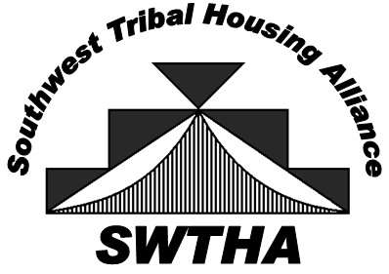

Arizona, New Mexico, and West Texas

PROXY

TO: Southwest Tribal Housing Alliance – SWTHA

I, ____________________, the designated Member’s Representative for the
(NAME)

____________________________, hereby authorize __________________
(NAME OF ENTITY) (NAME)

to vote on my behalf at the SWTHA Business Meeting on May 14, 2024 at Inn of the Mountain Gods, Mescalero, NM.

My authorization allows the above person to vote only as indicated below:

He/She agrees to accept this responsibility on my behalf:

G General Proxy
G Other: (indicate parameters)

Signature Title

Print Name Date

Please email to: Swtha.region8@gmail.com

