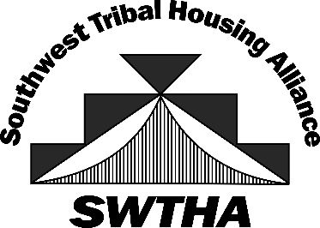
SWTHA Training
May 15, 2024
8:30am – 4:30pm
Inn of the Mountain Gods
Mescalero, New Mexico

DRAFT AGENDA

PART 1:
Presented by Native Community Capital
“How Native Community Development Financial Institutions (CDFI) Can Benefit TDHE Operations & TDHE Clients”
Learning Objectives:
- UNDERSTAND THE ROLE OF CDFI’S
  - Review Lending Data Specific to Tribes in Arizona & New Mexico
  - Learn the Requirements to become a CDFI
  - Review 3 Case Studies of Native CDFI’s in Indian Country
- REVIEW THE STATUS OF LENDING ON TRIBAL LANDS (Information for Your Partners)
  - Historical Context
  - Current State of Affairs
- LEARN TO DEVELOP LENDER RELATIONS (Information for Your Leadership)
  - Prescriptions for Enhancing Lender Relations
- DEMYSTIFY THE UNDERWRITING PROCESS (Information for Your Team)
  - Introduction to Lenders and Lenders’ Language (i.e., jargon)
  - Understand how the different stages of housing development relate to various lenders & types of financing
  - Introduce the Factors Lenders Use to Evaluate Risk
  - How to Evaluate Your Project from a Lender’s Perspective

PART 2:
Presented by the Southwest Native Assets Coalition
“An overview of Small Dollar Debt Consolidation Service Providers – Do’s and Don’ts and An Introduction to the Sovereignty through Education Curriculum”
Learning Objectives:
- BASIC MONEY MANAGEMENT: Help your clients understand the local economy, effective budgeting strategies, and the importance of saving by using tools for tracking expenses, setting financial goals, and making informed spending decisions.
- BUDGETING: Help your clients create and maintain a realistic budget that aligns with individual and family financial goals. Emphasis is placed on developing sustainable budgeting habits for long-term financial stability.
- HOME BUYING: Help your clients learn the pros and cons of home buying v renting. Topics covered include understanding mortgage options, navigating the real estate market, evaluating housing affordability, and securing financing.
- CREDIT MANAGEMENT: Help your clients understand credit scores, build and maintain good credit, and navigate the lending and debt management process.
- ASSET PROTECTION: Help your clients safeguard personal and family assets from financial risks and uncertainties. Topics include insurance coverage, estate planning, and financial planning from a cultural lens to protect individual and family assets.

