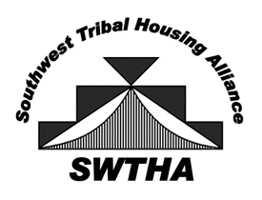
Southwest Tribal Housing Alliance
P.O. Box 10572
Albuquerque, NM 87184
swtha.region8@gmail.com
swtha.org
arizona – new mexico – west texas

SWTHA Scholarship Region VIII
Check List
_________________________________________

- Signed and Completed Scholarship Application

- Official Course/Grade Transcripts

- CIB/Enrollment Letter

- College Letter of Acceptance or Upcoming Class Schedule

- Essay

- 2 Letters of Reference

Applicants are hereby notified that applications that do not have the above-mentioned requirements will be considered incomplete and will not be considered for review by the Scholarship Committee.

