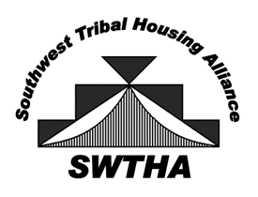
Southwest Tribal Housing Alliance
P.O. Box 10572
Albuquerque, NM 87184
swtha.region8@gmail.com
swtha.org
arizona – new mexico – west texas

January 15, 2024

Region VIII

Re: Notice of 2024 SWTHA Educational Scholarships

On behalf of the Southwest Tribal Housing Alliance (SWTHA) Board of Directors, I am pleased to announce the availability of educational scholarship grants for Region VIII (Arizona, New Mexico, and West Texas) funded under the AMERIND Risk’s Annual Scholarship Program. The goal of the scholarship grant is to assist in the education of American Indians and Alaskan Natives. The grant may be used for post-secondary or graduate level courses at an accredited educational institution for a course of study that will result in an accredited degree or vocational certification.

Please share this opportunity with your Education Department. All instructions are included in the program guidelines. The deadline for receipt of applications is April 30, 2024, by close of business. Please have completed applications mailed or emailed to:

Southwest Tribal Housing Alliance
P.O. Box 10572
Albuquerque, NM 87184
swtha.region8@gmail.com

The SWTHA Board is committed to assisting in the continued and progressive education of our Native American students, and we are pleased to offer this scholarship opportunity to our Region VIII post-secondary and graduate level students.

If you have any questions, please contact swtha.region8@gmail.com. Visit swtha.org for more information and updates. Thank you for providing this information to your community.

Sincerely,
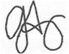
Greta Armijo
SWTHA Vice President

