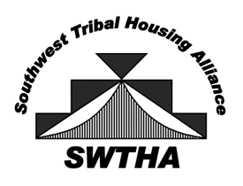
Southwest Tribal Housing Alliance
P.O. Box 10572
Albuquerque, NM 87184
swtha.region8@gmail.com
swtha.org
arizona – new mexico – west texas

December 1, 2023

Greetings Region VIII Member:

On behalf of the entire Southwest Tribal Housing Alliance (SWTHA) Board of Directors, thank you for all that you do to support tribal housing! Together, we can face the ongoing challenges through a collective voice of housing professionals to advocate for our communities, strengthen our voice for Native families, and increase homeownership on our respective tribal lands.
As 2023 comes to an end, we’re reaching out directly to our members across three states asking you to continue supporting SWTHA by renewing your membership and being an active member of our organization. Our mission “To be the voice for Tribal housing by providing relevant, timely information, resources, and a valuable network for the SWTHA membership” is done by:
- Providing a collective voice to local, state, and federal leadership on the ongoing issues facing American Indian Housing.
- Providing a place for discussion, resources, and assistance to those working to solve housing issues within our community.
- Keeping members informed on developments impacting Indian Housing.

Members receive a regular e-newsletter, can access current housing information on swtha.org, and are encouraged to participate in monthly meetings through a virtual platform on the second Tuesday of each month at 1:00pm (MST). Please plan to join us at our upcoming Triannual Meeting scheduled for January 23-24, 2024 in El Paso, Texas!
To renew, simply complete your Membership Form and submit with your payment.
In closing, while the work we do on behalf of our communities can be challenging, by working together to support, provide resources, and be the collective voice---we can make an impact!
Respectfully,
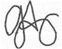
Greta Armijo
SWTHA, Vice President

Enclosed: Invoice and Membership Form

