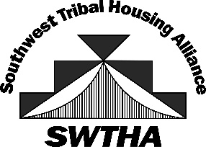
SOUTHWEST TRIBAL HOUSING ALLIANCE (SWTHA)
SCHOLARSHIP AWARDEES 2023

Beltran, Jennifer: Ysleta Del Sur Pueblo, University Texas El Paso, Nursing
Beltran, Manuel: Ysleta Del Sur Pueblo, El Paso Community College, Criminal Justice
Charlie, Megan: Pueblo of Acoma, University of New Mexico, Radiology Technology
Chee, Chance: Mescalero Apache, Western New Mexico University, Criminal Justice
Chino, Mallery: Pueblo of Acoma, Western New Mexico University, Social Work
Dewahe, Latisha: Pueblo of Zia, New Mexico State University, Anthropology
Farley, Xantia: Navajo, Ottawa University, Nursing
Fossum, Maekquin: Navajo, University of Arizona, Computer Engineering
Francis, James: Pueblo of Acoma, New Mexico State University, Counseling/Psychology
Jackson, Cheyenne: Navajo,San Juan College, Energy
Kallestewa, Jodi: Zuni Pueblo, New Mexico State University, Criminal Justice
Kirkman, Christian: Pueblo of Acoma, Arizona Christian University, Communications/Broadcast
Lent, Damaris: Mescalero Apache Tribe, UC San Diego, Public Health
Nez, Bailey: Navajo, Lawrence University, Environmental Science
Panana, Nevin: Pueblo of Jemez, Northern Arizona University, Forestry
Reynaga, Rachel: Ysleta Del Sur Pueblo, University of Arizona, Biology
Sandoval, Tierra: Navajo, Utah State University, Nursing
Williams, Lukaya: White Mountain Apache, Grand Canyon University, Government

Thank you to AMERIND for providing the Region VIII Scholarship Funds!

swtha.org ~ swtha.region8@gmail.com

