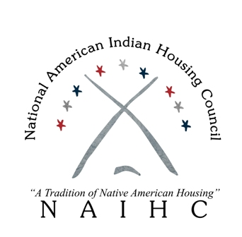

NAIHC 2023 Q1 Update
(edited January 6, 2023)

NAIHC News:
- NAIHC is seeking applicants for Executive Director position
  - https://naihc.net/executive-director-at-naihc/
- Thanks to All who attended our 2022 Legal Symposium!
- Training and Technical Assistance in 2023
  - Largely continuing trend of virtual trainings and in-person Technical Assistance
  - Some Trainings are scheduled for in-person as well, particularly those around Regional IHA meetings
  - NAIHC also assigned curated training-on-demand videos for core NAHASDA trainings, (not a recording of a live training, but scripted training to be recorded)
  - HUD ONAP Housing Summit planned for August 2023 in Minnesota
  - Homeowner Assistance Fund & Emergency Rental Assistance trainings/technical assistance is available on request directly to NAIHC:
    - https://naihcweb.wufoo.com/forms/wlik08p1ph88x3/
- Leadership Institute
  - Currently have 5 in-person courses scheduled:
    - Property Maintenance Management, March 21-23; Seattle, WA
    - Financial Management, April 25-27; Charlotte, NC
    - Resident Services, August 29-31; New Orleans, LA
    - Supervisory Management, September 19-21; Milwaukee, WI
    - Environmental Review, December TBD, Las Vegas, NV
  - Expect to add 1-2 more on NAHASDA- Tax Credit Compliance Professional courses
  - Online: Indian Housing Management course is available online
  - Pathways Homebuyer Education course also available online
    - TTA team selected a few programs active in Pathways to test in fall 2021
    - Provides training to the Housing professional & can be used with individuals in the community
  - Hopeful to produce 2-3 LI courses each year moving forward; Admissions & Occupancy and NTCCP are finalizing development
    - Targeting the full development of one certification track (Occupancy Management)
- NAIHC Rehab Grant (2020)
  - NAIHC awarded grants to 21 tribes for Rehab of Senior-owned homes during the spring of 2020
  - Work still ongoing in many communities due to COVID, extensions have been provided
  - Nearly all the projects have been completed/reimbursed
- NAIHC COVID Housing Assistance Grant (2021)
  - In March 2021, NAIHC awarded 19 grants to tribes for COVID-related housing projects, up to $44,000 per tribe
  - Nearly 3/4 of the grants have been completed/reimbursed
NAIHC Events:
- 2023 Legislative Conference Scheduled for March 6-7-8
  - Registration opening week of January 9
  - Schedule:
    - Monday, March 6: Advocacy 101, Legislative Conference, Reception
    - Tuesday, March 7: General Sessions, Panel Discussion
    - Wednesday, March 8: Hill Day, Group Meetings Scheduled
    - Expecting to Add HUD 184 Loan Guarantee Proposed Rule Consultation
- 2023 Annual Convention Save-the-Date
  - Waikoloa, Hawaii May 8-11
  - Registration opening late January
  - Schedule:
    - Monday, May 8: Golf Tournament, Service Project, Legislative Committee meeting
    - Tuesday-Thursday: Three full days – Opening/Closing Sessions, Breakouts, Organizations’ Members Meeting
  - Working with our Hawaiian hosts for cultural presentations, side events
  - Also going to work with Regional Housing Associations for Travel Scholarships (1 per region)
- 2023 Legal Symposium: TBD
  - NAIHC is looking to move the event to October (to avoid holidays/end of year)
  - Close to finalizing a conference site in Phoenix area
Other Meetings/Trainings:
- HUD Housing Summit 2023
  - Working with HUD/ONAP on bigger event
  - Already targeting August 2023
- HUD Regional Trainings:
  - Still finalizing full 2023 HUD Trainings Schedule (~50 trainings)
  - Some trainings are moving back to in-person
  - Check NAIHC’s website/calendar
  - Adding new online trainings sessions almost every week

Update on Pending HUD Grants & Comment Periods
- FY22 Grants:
  - FY22 ICDBG Annual Program
    - Issued July 19, DEADLINE October 24
    - ~$92 Million in awards
    - Waiting on Award Notifications
  - FY22 IHBG Competitive Grant
    - Issued July 26, DEADLINE November 17 NOW January 24, 2023
    - ~$130 Million in awards
- FY23 Grants:
  - FY23 ICDBG Annual funded at $75 million, NOFO TBD
  - FY23 IHBG Competitive funded at $150 million, NOFO TBD
- Comment Periods
  - ICDBG Imminent Threat Program
    - DTLL went out October 21, 2022
    - DEADLINE January 6, 2023
    - Asks for feedback on grant ceilings, programmatic improvements
  - HUD 184 Loan Guarantee Proposed Rule
    - Published in Federal Register on December 21, 2022
    - DEADLINE March 17, 2023
    - Holding Several Tribal Consultations (regional and national)
  - HUD CDBG-Disaster Recovery program RFI
    - Notes that no tribe has received this grant, requests feedback on how to improve program for tribes (policy revisions, fund allocation, etc.)
    - DEADLINE February 21, 2023
  - HUD Office of Housing Counseling SOON

Treasury Funds
- Emergency Rental Assistance funding (meant to follow IHBG allocation formula)
  - $800M for tribal Rental Assistance coming from U.S. Treasury Department
  - Tribes can provide rental and utility assistance (including arrears) to members 80% AMI and other eligibility requirements
  - ERA grants should all be in closeout periods now.
    - Group A Tribes: (tribes that did not receive any reallocations)
      - Closeout Reports due on January 30, 2023
    - Group B Tribes: (tribes that did receive reallocations)
      - Final quarterly report due January 17, 2023
      - Closeout Reports due April 28, 2023
    - Closeout training hosted by Treasury on January 10, 2023, 3pm Eastern
      - LINK: https://ustreasury.zoomgov.com/j/1609759969
  - NAIHC is still working with Congress for options for any extension or flexibility on use of funds
- Homeowner Assistance Fund ~$500 M​
  - 5% set-aside of larger national program​ ($498M)
  - Operated through Treasury, Similar to Emergency Rental Assistance Program​
  - Tribal allocations follow IHBG formula (mechanism allows non-IHBG tribes to claim allocation as well)
  - Applications:
    - Tribes had to submit their intent to claim their HAF allocation by December 15, 2021.
    - As of October 2022, ~180 tribal HAF plans have been approved
    - Still ~100 tribes that have not submitted HAF plans
  - Treasury HAF guidance and more information found on US Treasury website HERE
- NAIHC has Training and TA available for HAF and ERAP issues. Apply at: https://naihcweb.wufoo.com/forms/wlik08p1ph88x3/

Legislative Updates:

117th Congress Wrap-Up:

- Congress adjourned before Christmas after passing the FY23 full year funding
  - Saw 2% increase to tribal housing programs
  - Unfortunately, did not include policy provisions regarding NAHASDA reauthorization or ERA extension
  - Did see NAHASDA reauthorization pass the Senate for first time since 2008
    - As part of the 2021 NDAA (not included in version that passed the House and signed by President)

Funding
- FY23 is fully funded through September 30, 2023
- FY23 package included ~2% increase for tribal housing programs
  - Full FY23 Appropriations passed on December 23:
  - Saw increases for IHBG, ICDBG, HUD 184 Loan Guarantee, and HUD-VASH grants
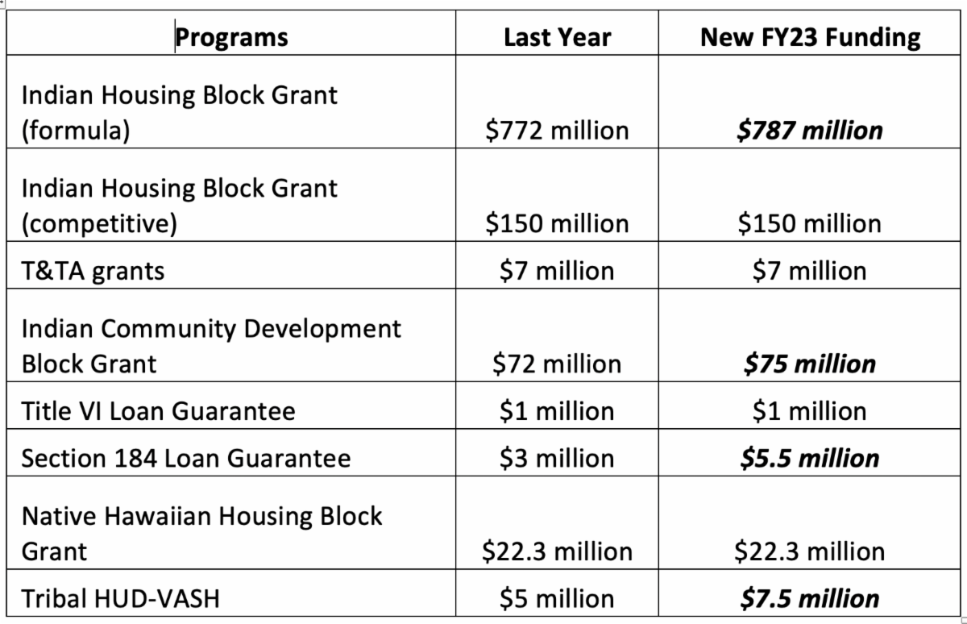
- FY2024 Budget
  - Administration typically sends budget to Congress in February/March
  - Congress then starts appropriations work
    - Committee hearings
    - Constituent Feedback
    - Member Priority Letters

NAHASDA Reauthorization

- Process to get NAHASDA reauthorized starts over in 118th Congress
- Three versions in prior Congress:
  - Senate Side: S. 2264
    - 13 bipartisan cosponsors: 9 Dems/4 Republicans
    - 10-year Reauthorization, Includes Hawaiians, Included Tribal Rent provisions
    - Passed Senate in 2021 as part of National Defense bill (NDAA)
  - House Side: H.R. 5195
    - 1 sponsor: Rep. Waters (D-CA)
  - American Housing & Economic Mobility Act: S. 1368, H.R. 2768
    - Sponsors: 7 Dem Senators/14 Dem Representatives
    - 10-year NAHASDA Reauthorization, $2.5 billion in Year 1, Access to Section 8 vouchers
- Strategy for 118th Congress is to get both chambers to introduce closer companion bills (more similar provisions than last year’s Senate and House versions)
  - Hopeful to pull best provisions from both versions
HUD-VASH
- Was included in the larger NAHASDA efforts, and introduced as a stand-alone bill in 2023
- Passed Senate in 2021 as part of NAHASDA package in NDAA
- In 118th, will again keep included in NAHASDA efforts and stand-alone
USDA Re-lending Bill
- S. 2092, H.R. 6331 both had bipartisan cosponsors in both chambers
- Bill would provide $50M from USDA Single Family Home Loan program to Native CDFIs to provide home loans in tribal communities
- More funding was included in FY23 final package, but not these policy provisions
- In 118th Congress, looking to include this and other tribal housing provisions in Farm Bill
Other Housing Bills
- S. 3381, Tribal Trust Land Homeownership Act
  - Four bipartisan cosponsors:
    - Thune (SD), Smith (MN), Rounds (SD), Tester (MT)
  - In 118th Congress, expect similar bill to be introduced in 118th Congress
- S. 4045, VA Native American Direct Loan Improvement Act
  - Led by Senator Rounds and Tester, would make improvements to VA NADL program:
    - Allow for NADL loans to cover refinancing existing mortgages
    - Provide grants to tribes to increase awareness among Native veterans
    - Provide a set-aside of NADL funds to Native CDFIs for greater loan deployment in tribal communities
  - In 118th Congress, expect to work with Veterans Affairs Leadership to re-introduce this bill
- Broken Promises bill
  - Last Congress, Senator Warren introduced bill that highlighted federal government’s shortcomings on all federal-tribal programs (including housing)
- Other legislative topics for tribal housing include:
  - Drug risks/Remediation funding (NAICH Resolution 2018-02)
    - Including in Senate NAHASDA version
  - Housing & Infrastructure connection (NAIHC Res. 2019-04)
  - Homeownership program improvements
    - 502 Single Family Loan, other USDA programs (NAIHC Res. 2018-01)
      - Senator Smith and Rounds introduced this bill on June 16
    - NADL improvements (NAIHC Res. 2019-03)
  - Section 8 and LIHTC improvements (NAIHC Res. 2018-03 & 2018-04)
    - Last Congress, bills did include restoring tribal access voucher program
      - Will also work with OMB to see if administration open to include tribal access to vouchers in budge process
    - Will work with LIHTC Leads in Congress to include tribal provisions
Overall reminders:
- Sign up online to receive newsletter by email every two weeks for recent updates
- Legislative Committee
  - Typically First Thursday of Each Month:
    - Thursday, February 2, https://zoom.us/j/97496787338
    - Monday, March 6 (in-person at Legal Symposium)
    - Thursday, April 6, https://zoom.us/j/97496787338
- Encourage vendors, product and service providers serving Indian country to become exhibitors at NAIHC events and/or Associate Members

