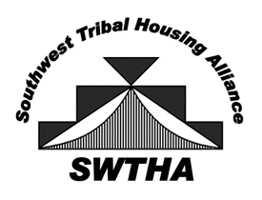
Southwest Tribal Housing Alliance
P.O. Box 10572
Albuquerque, NM 87184
swtha.region8@gmail.com
swtha.org
arizona – new mexico – west texas

November 12, 2021

Dear Region VIII Housing Director,

Let me start by thanking you for all the work you do to support tribal housing. Our work has challenges but it is rewarding to see our tribal nations make progress in housing initiatives even in a pandemic.
Your ongoing interest in SWTHA is appreciated. This letter serves as a SWTHA renewal membership reminder. Please continue to support SWTHA through a membership as we work to strengthen our voice for Native families.
The work of SWTHA has continued through COVID. SWTHA provided timely information on housing assistance funds and programs that were made available due to the pandemic.
Additionally, SWTHA represents our programs before state and federal legislators, and updates the members on new developments and issues. Members receive a regular e-newsletter and can access current housing information on the website.
Our virtual monthly meetings are held on the second Tuesday of the month at 1:00 pm MST. Our next Triannual Meeting is scheduled for January 26, 2022, more information will be forthcoming. As a member, you are invited to join the meetings.
We at SWTHA send you well wishes. Please visit swtha.org for more information and updates on housing events and news. We look forward to your continued support and participation in SWTHA's mission, to be the voice for Tribal housing by providing relevant, timely information, resources, and a valuable network for the SWTHA membership.
Sincerely,

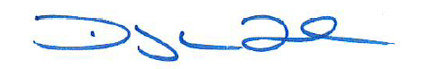

Floyd Tortalita
SWTHA President

Enclosed: Invoice and Membership Form

