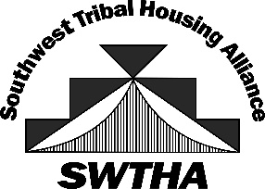

SOUTHWEST TRIBAL HOUSING ALLIANCE (SWTHA)
SCHOLARSHIP AWARDEES 2021

Freshman
- Tunte Baca: Mescalero Apache, Education, New Mexico State University
- Ethan Gallerito: Mescalero Apache, Computer Science, New Mexico State University
- Samantha Kazhe: Navajo Nation, Health Sciences, Fort Lewis College
- Martinez, Brynn: Mescalero Apache, Law, Grand Canyon University
- Antanaya Mendez: Mescalero Apache, Dental Hygiene, Dona Ana Community College
- George Rocha, Mescalero Apache, Business, University of New Mexico
- Kierston Vicenti: Jicarilla Apache, Biology, Colorado State University
- Madisyn Yuzos: Mescalero Apache, Health Sciences, Fort Lewis College

Sophomore
- Kalainia Waquie: Jemez Pueblo, Office Admin/Technology, Central New Mexico Community College

Senior
- Joseph Foy: Mescalero Apache, Cybersecurity, New Mexico Tech
- Keanna Lucereo: Pueblo of Isleta, Biology, University of New Mexico

Thank you to AMERIND for providing the Region VIII Scholarship Funds!

