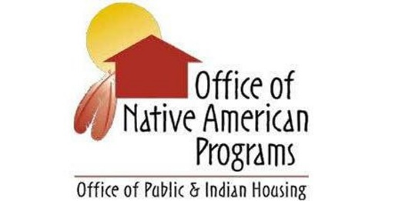
SWONAP Update Talking Points
SWTHA Triannual Meeting February 24, 2021

- Jody Moses, Administrator – Welcome/Introduction
- Cheryl Dixon-Zuni, Deputy Administrator - Welcome
- SWONAP Staffing Update
- Covid-19 and SWONAP Operations
  - Environmental
    - Ensure that you direct the public to send objections to HUD via email (POC for SWONAP is Debbie Broermann (Deborah.S.Broermann@hud.gov) – if you need this guidance or the email please contact either me or your GMS.
- Monitoring
- Codetalk Website
  - Dear Tribal Leader Letters (DTLL)
  - Training Announcements
- IHBG
  - PYE 6/30 FY 2021 IHP’s due April 17, 2021
  - Status of FY 2021 IHBG Final Allocations and Grant Agreements
- Indian Housing Block Grant Competitive Program
  - Status Update on Applications submitted 12.10.21
- ICDBG
  - No new info.
- IHBG CARES
  - Amendments
  - Supporting Access to Covid-19 Vaccinations
    - DTLL
- ICDBG CARES
  - PIH Notice 2021-06
- Tribal HUD VASH
  - Expansion NOFA published January 15, 2021
  - Applications due: April 15, 2021
  - DTLL issued providing Technical Correction to NOFA
- Section 3 Update
- Tribal Consultation Webex
  - February 25, 2021 Webinar
- Treasury Emergency Rental Assistance
  - Info of where to find info
- SWONAP Training and Technical Assistance
- SWONAP Disaster POC
- Closing

