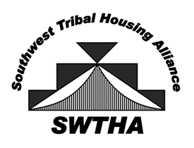
Southwest Tribal Housing Alliance
P.O. Box 10572
Albuquerque, NM 87184
swtha.region8@gmail.com
swtha.org
arizona – new mexico – west texas

December 1, 2020

Dear Region VIII Housing Director,

Greetings! Hope you and your loved ones are staying healthy during this time. Here at SWTHA we continue to stay connected during this global pandemic through monthly virtual meetings.
As always, thank you for your ongoing interest in SWTHA. This letter serves as a reminder it is time to renew your membership with SWTHA. COIVD-19 has brought tribal housing to the forefront exposing the gaps in resources for tribal housing. It is crucial that the tribal housing community continue to stay connected during these trying times. Please continue to support SWTHA through a membership as we work to strengthen our voice for Native families.
SWTHA offers trainings related to tribal housing and related services, represents our tribal housing programs before state and federal legislators, and updates the members on new developments and issues. Additionally, members receive a regular e-newsletter and can tap into the latest housing information on the website. Currently monthly meetings and triannual meetings are being held via Zoom. Each month we present a speaker with pertinent topics. The next triannual meeting will be February 24, 2021. As a member, you are invited to join the meetings.
Thank you for all the work you do to support tribal housing. Please visit swtha.org for more information and to keep updated on housing events and news. We look forward to your continued support and participation in SWTHA's mission, to be the voice for Tribal housing by providing relevant, timely information, resources, and a valuable network for the SWTHA membership.
Sincerely,

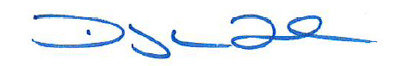

Floyd Tortalita
SWTHA President

Enclosed: Invoice and Membership Form

