HUD Tribal Interagency Advisory Committee

HUD posted notice seeking nominations for the new HUD Tribal Intergovernmental Advisory Committee. This Committee will facilitate communication between HUD and tribal leaders on housing priorities and strengthen capacity building opportunities. The Committee will enhance regular, meaningful consultation and collaboration between federal and tribal officials.

Here is a link to the Federal Register notice which announces the establishment of HUD's Tribal Intergovernmental Advisory Committee, and how to submit nominations. Nominations are due by February 21, 2017.
2016-30744 FR Notice Establishing TIAC 12-21-16 (3)

Housing Needs Study
On January 3, 2017, HUD published "Housing Needs of American Indians and Alaska Natives in Tribal Areas: A Report From the Assessment of American Indian, Alaska Native, and Native Hawaiian Housing Needs: Executive Summary". This report summarizes principal findings and conclusions of the Assessment of American Indian, Alaska Native, and Native Hawaiian Housing Needs, a congressionally mandated study. Read the Executive Summary here.
2017 Legislative Conference-
March 6-8

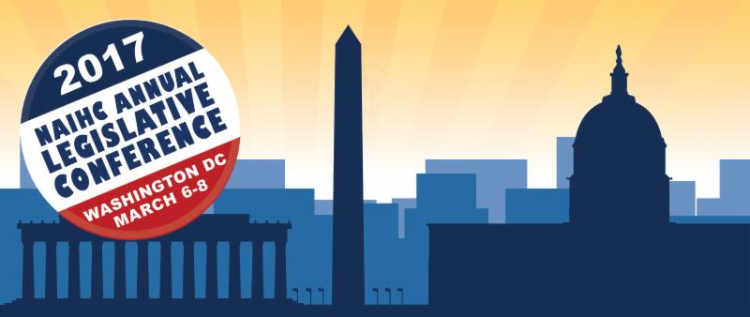
The decisions made by Congress and the Administration in Washington, DC, directly affect you and all of Indian Country. NAIHC's Annual Legislative Conference offers tribes, TDHEs, and Housing Authorities a chance to take part on the process. Attendees can discuss-with each other and with representatives of the federal government-the scope and impact of legislative issues affecting Indian Country. The event brings tribal housing representatives face-to-face with lawmakers, both during the conference and during Congressional visits on Capitol Hill.

2017 Calendar 115th Congress

House and Senate leadership released calendars for the first session of the 115th Congress in 2017. Both chambers will be in session for a total of 139 days. The Senate is schedule to be in session for an additional 50 days for a total of 189 days in session and the House is schedule to be in session for an additional six days for a total of 145 days in session.
The chambers will recess the third full week of February, the second and third weeks of April, the first week of July, the entire month of August, the third full week of November, and the last two weeks of December. See the calendar from CQ Roll Call below for a visual representation.

PDF Version:
2017 Congressional Calendar

Dear Tribal Leader letter on MOU and Statement - Environmental Reviews for Housing and related projects in Indian Country ( Comments due February 12, 2017.)

As the lead agency in the federal effort to develop a coordinated environmental review process for housing and housing-related infrastructure in Indian Country, HUD issued a Dear Tribal Leader letter requesting review and comments on the draft interagency Memorandum of Understanding and its companion draft Statement of Intent, which are intended to encourage the use of tools that can streamline the federal environmental review process. The final documents will be used by entities, including tribes, that are responsible for conducting federal environmental reviews.

NAHASDA Reauthorization Legislation of the 115th Congress
The Native American Housing Assistance and Self-Determination Act of 1996 (NAHASDA) is a powerful tool that provides greater housing opportunities and housing related community development in tribal communities. Since originally signed into law, NAHASDA has been reauthorized and amended several times. While the intention of each amendment is to improve the Act, there are still further refinements that may enhance the overall effective and efficient delivery of housing programs in tribal communities.
On January 14, 2015, H.R. 360, a bill to reauthorize NAHASDA was introduced by Representative Steve Pearce (R-NM) and 17 co-sponsors. Developed and championed by the National American Indian Housing Council (NAIHC), H.R. 360 would have expedited required federal approvals, authorize tribes to blend housing construction money with sanitation facilities funding, launch a demonstration program for alternative privatization authority for Native housing, and other reforms. H.R. 360 was adopted by the House of Representatives on March 23, 2015 and referred to the Senate. A companion bill, S. 710 was introduced by Senator John Barrasso (R-WY) March 11, 2015. HR360 and S710 did not pass the full Senate.

The next step is introduction of a new NAHASDA reauthorization bill. The NAIHC is diligently working to line up sponsors and ensure quick passage in both chambers of Congress.

* * * *

