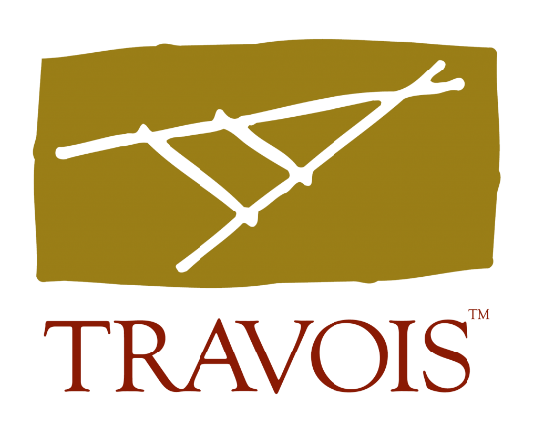

Here’s a little more information about the New Markets Tax Credit program:
The NMTC is a federal economic development incentive program that attracts private investor capital to community economic development projects. Created in 2000, the NMTC has attracted billions to business, health care, education and other projects across America.
Administered by the Community Development Financial Institutions Fund (CDFI Fund), the NMTC program allocates NMTCs to Community Development Entities (CDE). CDEs partner with leverage lenders and NMTC investors to provide low-cost, flexible debt or equity to projects.
As an independent CDE, Travois works with a vast network of leverage lenders and NMTC investors to serve Native communities. Our goal is to see that Indian Country, Alaska Native areas and Native Hawaiian communities reap the full potential benefit of the NMTC program.
NMTCs are allocated nationwide, and competition among project sponsors is intense. As an advocate for Indian Country, we leverage our national relationships to secure NMTC allocation and investment equity for our service area.
There are a few restrictions on the use of NMTCs. We cannot finance casinos, racetracks, liquor stores, massage parlors, farms, golf courses or financial businesses.

