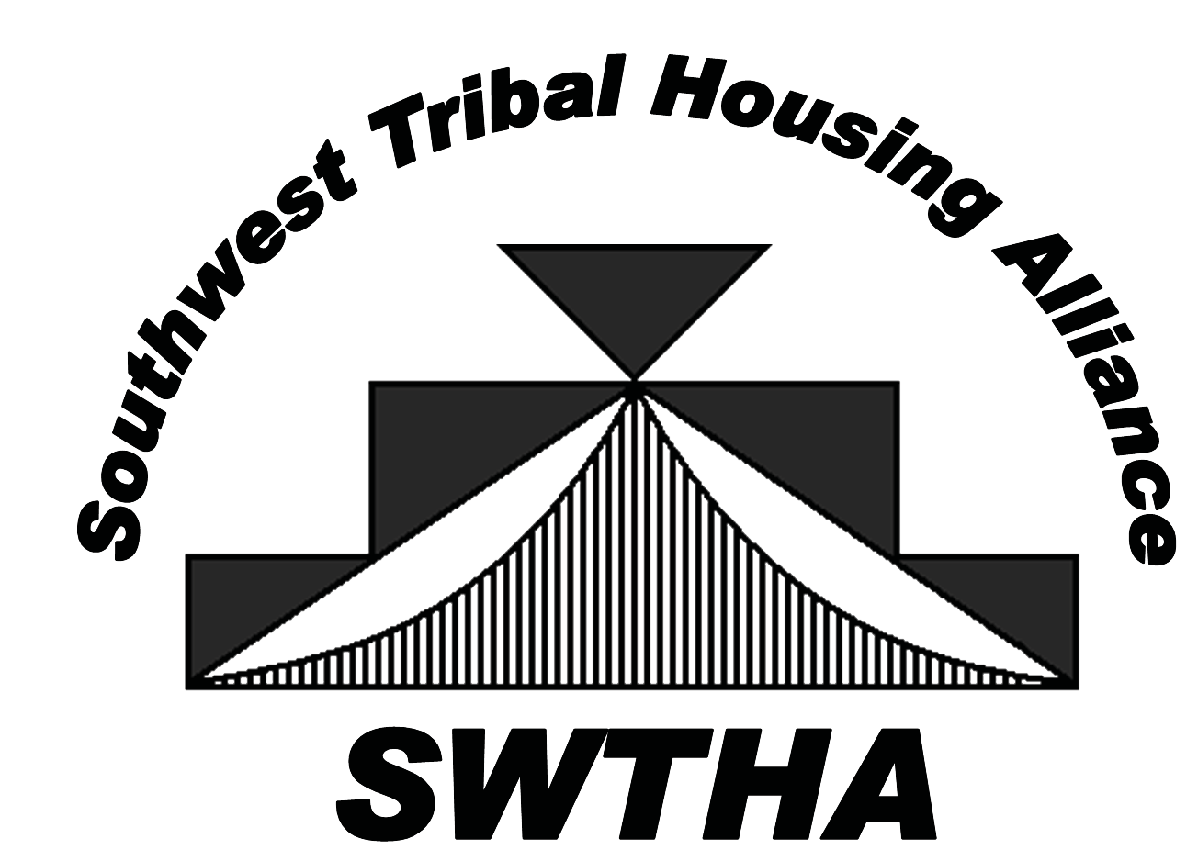

ESTABLISHED IN 2009, SWTHA is a relatively new

organization gaining strength and, as membership numbers increase, the strength of the alliance builds. Through the alliance, Tribal housing authorities support one another to ensure that unique Tribal housing needs and interests are recognized and addressed.

**Southwest Tribal Housing Alliance**

VISION: Region VIII Tribal Housing Advocate

MISSION: To be the Southwest Tribal voice   
of housing by providing relevant, timely information, resources and a valuable network for the SWTHA membership

**Region VIII: Representing Arizona, New Mexico and West Texas—Tribes, Pueblos and Nations**

Reasons to Join: *SWTHA Membership Benefits*

■ More members mean a stronger voice for Native families.

■ A reasonable membership fee of only $250 per year.

■ Educational opportunities:

*> Technical training and assistance to increase administrative capacities.*

*> Access to regional and national speakers on regulatory compliance, development, finance, economic development, environmental, legal and other topics related to affordable housing.*

■ National and regional advocacy specifically for New Mexico,

Arizona and West Texas Tribal communities.

■ Scholarship opportunity:

> $5,000 awarded annually to the region sponsored by AMERIND Risk Management.

■ Annual Membership Meeting.

■ Strong partnerships with housing organizations such as

the National American Indian Housing Council.

“It is powerful to see the impact an alliance of devoted entities can make in a community. I have seen the members of the Southwest Tribal Housing Alliance do a tremendous job of representing Indian Housing Authorities, TDHEs and Tribes in providing a hand up to deserving families on tribal lands.”

SWTHA BOARD MEMBERS AND REPRESENTATIVES

**Nadie Beauty, Board Member**

*Arizona Representative*

(928) 567-4191

[nbeauty@yan-tribe.org](mailto:nbeauty@yan-tribe.org)

**Marlene Garcia, Board Member**

*Arizona Representative*

(520) 568-1733

[magarcia@ak-chin.nsn.us](mailto:Way.callado@yahoo.com)

**Greta Armijo, Board Member**

*New Mexico Representative*

(505) 465-1003

greta.armijo@jemezpueblo.org

**Nadine Encino, Board Member**

*New Mexico Representative*

(505) 552-6430

[nadinee@lagunahousing.org](mailto:nadinee@lagunahousing.org)

**Veronica Ruiz, Board Member**

*West Texas Representative*

(915) 859-9196

[vruiz@ydsp-nsn.gov](mailto:vruiz@ydsp-nsn.gov)

*\*Please direct all general inquiries to SWTHA Vice President and membership information to SWTHA Treasurer.*

SWTHA BOARD   
OF DIRECTORS

**Floyd Tortalita, President** *Region VIII AMERIND Alternate Representative*

(505) 552-7528

[ftor](mailto:ftortalita@acomahousing.org)[talita@acomahousing.org](mailto:talita@acomahousing.org)

**Michael Chavez, Vice President**

*Region VIII NAIHC Alternate*

(505) 782-4553

[mchavez@pozha.org](mailto:mchavez@pozha.org)

**Nina Jaramillo,**

**Secretary/ Treasurer**(505) 771-2060 [nina.Jaramillo@santaana-nsn.gov](mailto:nina.Jaramillo@santaana-nsn.gov)

# —Floyd Tortalita, former Governor of Acoma

**Call, mail, email or visit us!**

[swtha.r](mailto:swtha.region8@gmail.com)[egion8@gmail.com](mailto:egion8@gmail.com) SWTHA.org

PO Box 10572

Albuquerque, NM 87184

**Lisa Manwell, Board Member**

*Region VIII AMERIND Representative*

(575) 759-3415

[lgm@jaha1.org](mailto:lgm@jaha1.org)

**Brook Kristovich, Board Member**

Region VIII NAIHC Representative

(505) 465-1003

bkristovich@sdtha.org