trust responsibility: meeting tribal housing needs in the southwest
  - White Paper by the Southwest Tribal Housing Alliance (SWTHA) January 2019

PRIORITIZING AND REAUTHORIZING NAHASDA
about swtha
The Southwest Tribal Housing Alliance (SWTHA) is the Region VIII representative organization to the National American Indian Housing Council (NAIHC). SWTHA represents the Native American housing interests of organizations in Arizona, New Mexico and West Texas.

contact swtha
P.O. Box 710
Zuni Pueblo, NM 87327
928-769-6188
swtha.region8@gmail.com
www.swtha.org

F
F
F
F
F

P.O. Box 710
Zuni Pueblo, NM 87250
928-769-6188
swtha.region8@gmail.com
www.swtha.org

The top issue, and concern, for tribal housing members of the Southwest Tribal Housing Alliance (SWTHA) is the reauthorization of the Native American Housing Assistance and Self-Determination Act (NAHASDA), significant legislation enacted in 1996 that authorizes tribes to manage their own housing programs, which expired in 2013. By reducing restrictive federal regulations, NAHASDA allows tribes to exercise its self-determination and self-governance by assessing and providing quality, affordable housing to its tribal members through block grants. Despite, reauthorization bills failing to move out of committee in the previous two Congressional sessions, tribes in Region VIII continue to use NAHASDA to offer housing opportunities and housing-related community development projects to their community members. While overall conditions in Indian Country remain poor, housing conditions have improved as a result of NAHASDA. Consequently, reauthorization of NAHASDA, a powerful tool, would bring program stability and funding security to tribal housing entities in Region VIII and throughout Indian Country. SWTHA strongly urges allies within the Senate and House of Representatives to introduce a reauthorization bill that will benefit all tribes.

investing in tribal housing – congressional appropriations
For NAHASDA to work, funding is essential. Since fiscal year 2011, Congressional appropriations for the Indian Housing Block Grant (IHBG), the primary funding source for tribal housing, has remained stagnant at $650 million. The fiscal year 2019 appropriations bill for the Department of Housing and Urban Development (HUD) funds IHBG at $775 million and zeros out funding for the much-needed, much-used Indian Community Development Block Grant (ICDBG). Region VIII tribes heavily rely on the ICDBG program to fund infrastructure and rehabilitation services for low-income homeowners, and any cuts to the program will have devasting effects on the tribal economy and community development. Even if IHBG is funded at $775 million, this funding will not meet all tribal housing needs, but rather will keep pace with the increased cost of housing construction, energy costs and other inflationary factors.

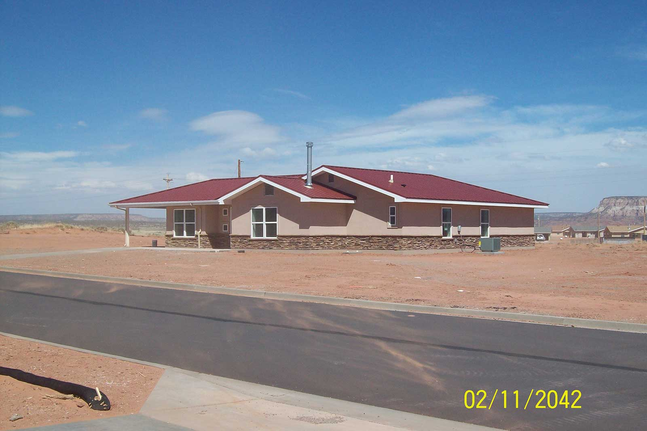
SWTHA urges Congress to fund housing and community development programs at the following amounts:
Indian Housing Block Grant (IHBG): Fund at no less than $700 million. IHBG funds are used for housing development, housing‐related infrastructure and home repair and maintenance.
Indian Community Development Block Grant (ICDBG): Fund at no less than $100 million. ICDBG enables tribes to increase commercial, industrial and agricultural projects.
Title VI Loan Guarantee Program: Fund at $2 million. Title VI funds assists tribes with rental assistance, development and management services, crime prevention and safety and model activities.
Zuni Housing Authority's Bluebird Housing Division.
Section 184 Home Loan Guarantee Program: Fund at $10 million. Section 184 loans helps tribal members purchase a new home or rehabilitate an existing home or both.
SWTHA Vision
Region VIII Tribal Housing Advocate.

SWTHA MISSION
To be the Southwest Tribal voice of housing by providing relevant, timely information, resources and a valuable network for the SWTHA membership.

Tribal HUD-Veterans Affairs Supportive Housing (VASH) Program: Fund at $7 million. HUD-VASH funds help Native veterans who are at-risk or homeless with housing opportunities.
NAHASDA Training and Technical Assistance: Fund at no less than $4.8 million. Technical assistance dollars help tribes navigate HUD regulations and applicable laws while trainings expand knowledge of operation and management.
Native Hawaiian Block Grant: Fund at $20 million. Adequate funds will increase the supply of affordable housing units and rehabilitate existing units.
BIA Housing Improvement Program (HIP): Fund at its previous level of $23 million. BIA HIP helps with home repair, renovation, replacement and new housing.
USDA Rural Development 502 Direct Loan Program: Fund a set-aside of $50 million to establish a demonstration relending program in Indian Country.
VA Native American Director Loan Program: Fund a set-aside of $10 million to establish a demonstration relending program for qualified Native American veterans.

Leveraging IHBG and USDA Rural Development funds, Zuni Housing Authority constructed 54 homes for low-income families.

Though funding for NAHASDA programs remain inadequate, SWTHA tribes are using IHBG and ICDBG money to provide homes for low-income families and rehabilitate houses for elderly and disabled tribal members. For example, the Zuni Housing Authority used IHBG and USDA Rural Development funds to construct 54 homes and the Pueblo of Acoma Housing Authority used ICDBG funding to address overcrowding and fix houses without suitable plumbing. Despite fiscal challenges, funding tribal housing programs in the southwest is working and worth the investment to provide families, elders and first-time homeowners with quality housing on their respected homelands.

funding for tribal leasing regulations
The Helping Expedite and Advance Responsible Tribal Homeownership (HEARTH) Act of 2012 allows tribes to opt out of Secretarial approval requirements for tribal leases, and to develop and implement their own leasing regulations to meet their own needs—but it does not provide funds for technical assistance and support services to implement the regulations. Currently, 26 tribes are operating its own leasing administration—such as land surveying, reviewing leases and conducting environmental reviews—while many tribes are unable due to lack of funding. SWTHA requests funding to implement HEARTH which, in turn, will help remove barriers to mortgage financing on tribal lands.

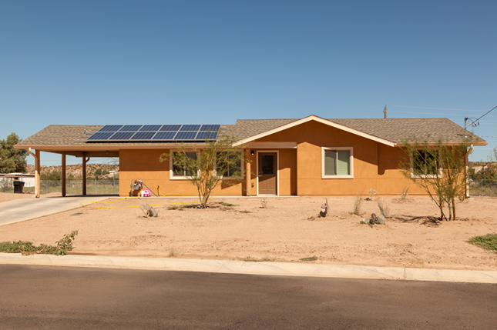
coordinating Environmental reviews
Tribal housing entities collect funds from several different federal sources to build new homes or community projects, which means compling with several different agency environmental review guidelines. For example, if a tribal housing program plans to build an apartment complex using HUD, USDA and BIA funding, then the housing program must adhere to enviornmental review guidelines from HUD, USDA and BIA. Some projects may require more than three different guidelines to ensure the projects will not have an adverse environmental or health effect on residents or negatively impact the surrounding environment. In 2016 HUD started encouraging the use of three different tools to help federal agencies and tribes streamline the process: the Incorporation by Reference, Cooperative Agency Agreements and Adoption. SWTHA members agree that all federal agencies dealing with tribes should adopt a consolidated environmental review process.
San Carlos Housing Authority home.

SWTHA asks Congress to reintroduce a legislation that considers the following:
- Development of a singular process to be used by all federal agencies in conducting environmental reviews;
- Identification of specific tribal and tribal program responsibilities regarding environmental reviews; and
- Coordination of combined training about environmental reviews that involves all federal agencies that deal with tribes.

Housing opportunities for veterans
In 2014, Congress passed legislation to set up a pilot initiative to provide Native American veterans access to housing funds. Prior to 2015, tribes and tribal housing authorities were unable to access veterans housing funds even though Native Americans serve in the military at a higher percentage than any other ethnic group. Currently, 25 tribes participate in the pilot initiative, which has helped house over 250 Native veterans.

Through HUD-VASH funding and by expanding their service area, Zuni Housing Authority provided 10 tribal members with subsidized housing in Zuni, Gallup and Albuquerque.

The Tribal HUD-Veterans Affairs Supportive Housing (VASH) program has helped to bridge tribes and veterans with opportunities and housing. For example, through HUD-VASH funding and by expanding their service area, Zuni Housing Authority provided 10 tribal members with subsidized housing in Zuni, Gallup and Albuquerque, New Mexico. In 2017, legislation was to introduced to amend the Housing Act of 1937 to require HUD to use at least 5% of low-income housing assistance funds to benefit Native American veterans. SWTHA urges allies in the Senate and House to reintroduce similar legislation in the 116th Congress.

equal access to housing
In September 2016, HUD issued a final rule "Equal Access in Accordance with an Individual's Gender Identity in Community Planning and Development Programs" that ensures that HUD's housing programs are open to all eligible individuals and families regardless of sexual orientation, gender identity or marital status. Though supportive of the progressive move toward housing equality, several tribes tribes are concerned with this rule encroaches upon their sovereignty and self-determination. Tribes are held to the rule and prohibited from considering marital status in determining eligibility for occupancy in their managed units or in the provision of other affordable housing-related activities. SWTHA requests that HUD amend the rule to ensure tribes’ sovereignty is protected.

meaningful tribal consultation
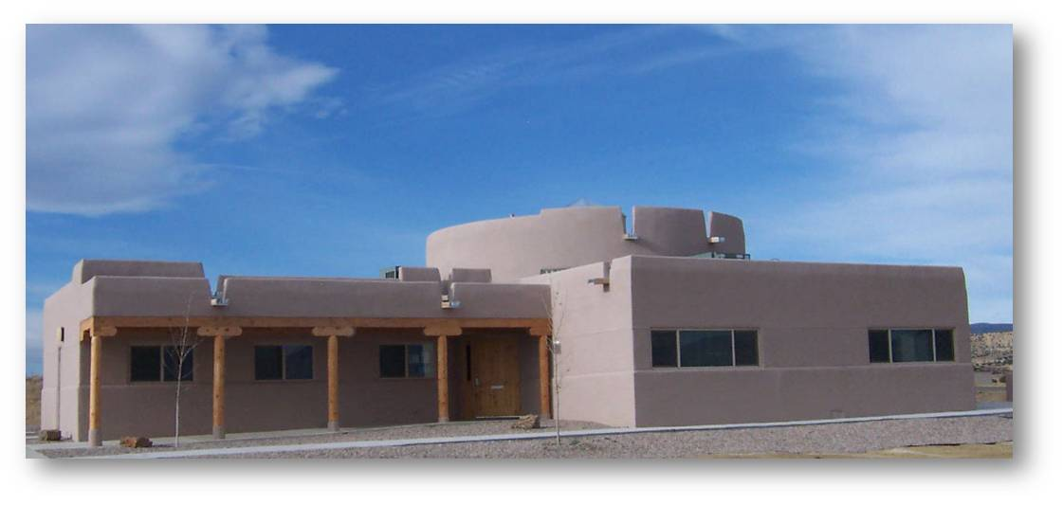
It is imperative that federal agencies actively and frequently engage in meaningful consultation with tribes, specifically before any formal or official platforms have been agreed upon. Consultation is an true example of a working government-to-government relationship and often eliminates barriers to progress or catches issues of concern. Unfortunately, many federal agencies have a history of engaging tribes for input too late in the process or only on a review basis. For example, HUD proposed and issued several actions in recent years for which there was little to no consultation with tribes, such as for the “Establishment of a Tribal Intergovernmental Advisory Committee.” Further, the USDA held a tribal consultation at a national Indian orgnization convening, but to much disappointment the meeting was more informative in nature and not true tribal consultation. Issues in Indian Country are often more complex than they seem at first, in part because of the great diversity among tribes. An open process in the initial stages creates better and more efficient consultation. SWTHA urges HUD, USDA and other federal agencies to better engage in meaningful government-to-government tribal consultation with tribes in accordance with Executive Order 13175, Consultation and Coordination with Indian Tribal Governments.
Pueblo of Acoma Housing.

ASSURING negotiated rulemaking ENGAGEMENT
SWTHA members agree that HUD must adhere and held accountable to the negotiated rulemaking process when regulatory changes are needed. In the past, HUD has not followed the negotiated rulemaking process resulting in unsupported changes. For example, HUD did not engage in negotiated rulemaking for the “Implementation of the Tribal HUD-VA Supportive Housing Program” and its potential effects on funding and programs subject to NAHASDA. This way of doing business with tribes is unacceptable. SWTHA and tribes throughout Indian Country require assurances from HUD that it will provide for negotiated rulemaking regarding any regulatory changes and its potential effects.

SWTHA RESOLUTION 2019-01
The Resolution requests Federal Legislation Providing Tribes An Exemption To The Requirements Of The Federal Flood Disaster Protection Act Of 1973. The Act prohibits the use of federal funds, including the Indian Housing Block Grant (IHBG) and the Indian Community Development Block Grant (ICDBG) on sites that FEMA has mapped as being in a special flood hazard area (SFHA), unless a community or tribe participates in the National Flood Insurance Program (NFIP) which imposes flood insurance requirements and building restrictions. Adopting an approved NFIP flood ordinance is a burdensome and costly process that requires a tribe to hire a certified flood plain manager, develop and enforce flood standards, require certified elevations when building or rehabilitating on floodplains, and maintain tribal records on all new home construction and rehabilitation. States are granted an exemption from the Act’s requirements that a community join the NFIP before using federal funds on floodplains and said exemption is found at 42 U.S.C. 4003(a)(3). The state exemption applies to federal affordable housing funds provided to states, including HOME funds and CDBG funds, and HUD regulations at 24 CFR 58.6(a)(3), the HUD environmental regulations, and 24 CFR Part 55.1 (b)(1), the HUD floodplain management regulations. SWTHA requests Congress to sponsor federal legislation providing a tribal exemption to the requirements of the Act, similar to the exemption available to states.
SWTHA Board of Directors  Floyd Tortalita, President  and Region VIII AMERIND Alternate Representative  (505) 552-7528  ftortalita@acomahousing.org  Michael Chavez, Vice President  and NAIHC Alternate Representative  505-728-4553  mchavez@pozha.org  Nina Jaramillo, Secretary/Interim Treasurer  (505) 771-2060  Nina.Jaramillo@santaana-nsn.gov | SWTHA Board Members & Representatives  Marlene Garcia, Board Member  Arizona Representative  520-568-1733  magarcia@ak-chin.nsn.us  Nadie Beauty, Board Member  Arizona Representative  (928) 567-4191  nbeauty@yan-tribe.org  Veronica Ruiz, Board Member  West Texas Representative  (915) 859-9196  vruiz@ydsp-nsn.gov | Greta Armijo, Board Member  New Mexico Representative  (505) 465-1003  greta.armijo@jemezpueblo.org  Nadine Encino, Board Member  New Mexico Representative  (505) 552-6430  nadinee@lagunahousing.org  Lisa Manwell, Board Member  Regional VIII AMERIND Representative  575-759-3415  lgm@jahal.org  Brook Kristovich, Board Member  NAIHC Representative  (575) 464-9259 bkristovich@mescaleroapachetribe.com

