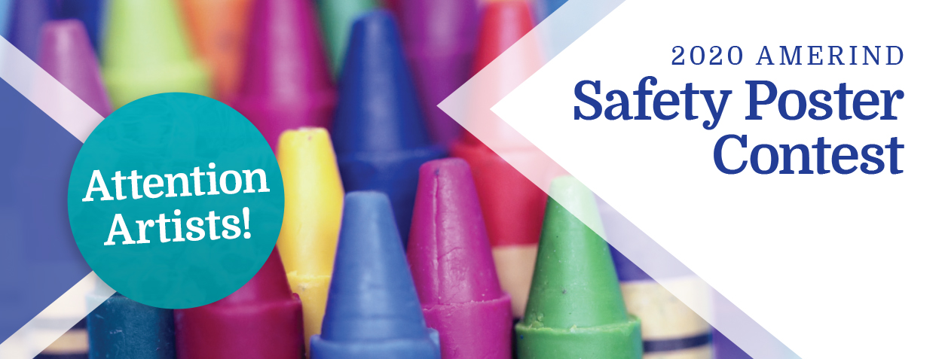

Attention Artists!
Submit your safety themed poster to your local housing authority. You could win $1,000!
National winner in each category (K-3, 4-6, 7-8) receives $1,000.

Before You Get Started!
1. MATERIALS:
Use blank 8.5 x 11 sheet of paper.
2. CLEARLY PRINT:
• First, Last Name
• Grade
• Tribal Affiliation
• Phone Number
• Housing Authority
3. BEGIN:
Turn paper over and create your masterpiece.
If you have any questions, please call the AMERIND Risk Safety Team at 800-352-3496. The purpose of AMERIND’s annual poster contest is to promote Safety in our communities.

