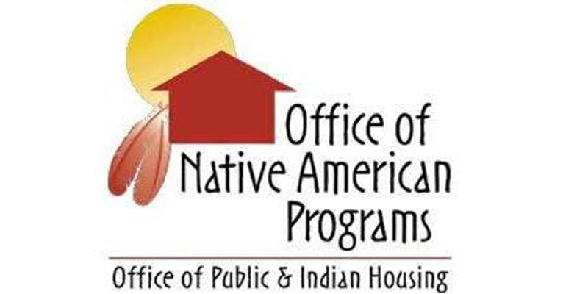
HUD’s Southwest Office of Native American Programs is pleased to share the following information about upcoming FREE Trainings.
July 9-10
Tribal Housing Maintenance and Operations
Albuquerque, NM
Tribal housing maintenance expenses can be controllable. This 2-day course is designed as an introduction for new maintenance professionals or as a refresher for the veteran employee, to provide these professionals with the knowledge and tools necessary to run an effective housing maintenance program. Trainers will provide information, tips and guidance to identify maintenance issues, track, schedule, and complete maintenance and repairs. Register at www.FirstPic.org/events .
July 9-11
Grant Writing for Tribes
Reno, NV
Register today!: https://www.eiseverywhere.com/ereg/index.php?eventid=453523&
This 2.5-day course will cover strategies for effective grant writing for affordable housing, homeownership and community development; program capacity building; and resident services/self-sufficiency activities. On the first day, participants will discuss how to assess their funding needs and identify possible sources of public and private sector funding. On day two, they will learn about the key components of a typical funding proposal including a statement of need, program goals, management capacity, implementation schedules, intended program outputs and outcomes, evaluation and long-term program sustainability. Participants will have the opportunity to expand their skills to prepare competitive funding proposals and will explore other revenue generating strategies through social enterprises, fee-for-service, and event sponsorships. The final half-day will include interactive exercises to test participant knowledge and peer sharing discussions about fundraising and grant writing tips and tools.
For more info., contact Shane Begay at sbegay@naihc.net or call (202) 454-0936.
July 15-19
Pathways Home
Phoenix, AZ
Participants learn how to deliver comprehensive homebuyer education program designed to help educate prospective native homebuyers on how to become successful homeowners. The curriculum is specifically tailored for Native American communities. Participants will also learn the most effective methods to help potential homebuyers determine what is best for them; to build a new home or to buy an existing one. Other areas covered in this curriculum include understanding the mortgage loan process, how to prepare a family budget, how to improve credit profiles, how to avoid the pitfalls of predatory lending, foreclosure prevention strategies, and how the family can maintain the home and their personal finances after the purchase. Instructors specialize in homebuyer education & include culturally relevant teaching techniques. Details & Registration: https://www.eiseverywhere.com/ereg/index.php?eventid=423433&
July 22-26
NAHASDA Boot Camp
Billings, MT
This 4 ½ day class is intended for those new to Indian Housing, including housing employees, Housing Board members, elected Tribal leaders and those wishing to learn the basics of contemporary Indian housing. The class will cover all of the requirements of the Indian Housing Law...read more. Register Here: http://naihc.net/july-22-26-nahasda-bootcamp-billings-mt-registration-open/

July 23-25
NAHASDA Essentials
Reno, NV
This exciting and interactive 3-day training provides attendees with a comprehensive introduction to NAHASDA. Participants will become familiar with all program activities, including rental housing, homebuyer programs, rehabilitation, and housing and crime prevention services. Other topics covered include the IHBG formula, eligible program participants, income verifications, other federal requirements, financial management and program administration. This foundational course will acquaint tribal and TDHE staff with the basic requirements of the IHBG Program and opportunities that are available. The training will be presented through case studies, group discussions, team games, lectures and hands-on exercises. Register at http://newregistration.firstpic.org/.
COMING SOON - Save the date:
August
Leveraging HUD’s Loan Guarantee Programs (Title VI and Section 184)
Phoenix, AZ
Learn about HUD’s Section 184 and Title VI Loan Guarantees. The Section 184 Indian Home Loan Guarantee Program is a home mortgage product specifically designed for American Indian and Alaska Native families, Alaska villages, tribes, or TDHEs. With Section 184 financing borrowers can get into a home with a low down payment and flexible underwriting. Section 184 loans can be used, both on and off native lands, for new construction, rehabilitation, purchase of an existing home, or refinance. Title VI is an effective public investment tool for federally recognized tribes and TDHEs providing an additional source of financing for affordable tribal housing activities including new construction, rehabilitation, infrastructure, community facilities, land acquisition for housing, and much more!
Planning is in progress. More details to follow.

Fall 2019
Green Building & Sustainable Construction
Phoenix, AZ
Planning is in progress. More details to follow.

Sept. or Oct. 2019
Financial Management & Recordkeeping
Albuquerque, NM
Learn the components of an effective financial management system, including discussions of the various control systems including Internal Controls, Budgeting, Cash Management, Accounting Controls, Procurement, and much more. More details to follow.
Late Fall 2019
Infrastructure Development and Financing for Tribal Projects
Phoenix, AZ

Planning is in progress. More details to follow.

