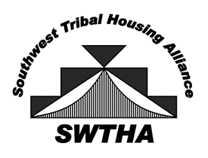
Southwest Tribal Housing Alliance
C/O William Picotte
SWTHA President
Gila River Indian Community Housing
P.O. Box 52
Sacaton, AZ 85147
william.picotte.dch@gric.nsn.us
(520) 562-3904
arizona – new mexico – west texas swtha.org

April 2, 2019

SWTHA Membership

Re: Notice of 2019-20 Educational Scholarships

On behalf of the Southwest Tribal Housing Alliance (SWTHA) Board of Directors, I am pleased to announce the availability of educational scholarship grants for Region VIII (Arizona, New Mexico, and West Texas) funded under the AMERIND Risk’s Annual Scholarship Program. The goal of the scholarship grant is to assist in the education of American Indians and Alaskan Natives. The grant may be used for post-secondary or graduate level courses at an accredited educational institution for a course of study that will result in an accredited degree or vocational certification.

Please review the attached application and guidelines carefully. Also note the deadline for receipt of applications is April 22, 2019 by close of business. The announcement of the scholarship recipients will be made during the SWTHA Membership Meeting on May 6, 2019. The meeting is in conjunction with AMERIND/NAIHC Annual Convention and Trade Show, Denver, Colorado, on May 7-9, 2019.

The SWTHA Board is committed to assisting in the continued and progressive education of our Native American students, and we are pleased to offer this scholarship opportunity to our Region VIII post-secondary and graduate level students.

If you have any questions, please feel free to contact Mr. Floyd Tortalita at (505) 552-5174, or email ftortalita@acomahousing.org. Visit swtha.org for more information and updates.

Sincerely,

William Picotte
SWTHA President

