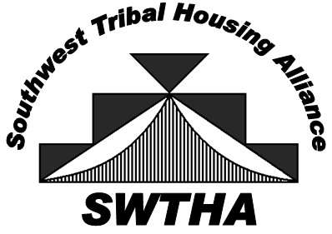

Arizona, New Mexico, and West Texas

PROXY

TO: Southwest Tribal Housing Alliance – SWTHA

FROM:
(Tribe, TDHE, Pueblo or Housing Authority)

I hereby authorize from
(Name) (Tribe, TDHE, Pueblo or IHA)

to vote on my behalf at the SWTHA Business Meeting on
May 6, 2019 at the Colorado Convention Center, Denver, CO.

My authorization allows the above person to vote only as indicated below:

He/She agrees to accept this responsibility on my behalf:

G General Proxy
G Other: (indicate parameters)

Signature Title

Print Name Date

Please email to:
Michael Chavez mchavez@pozha.org

