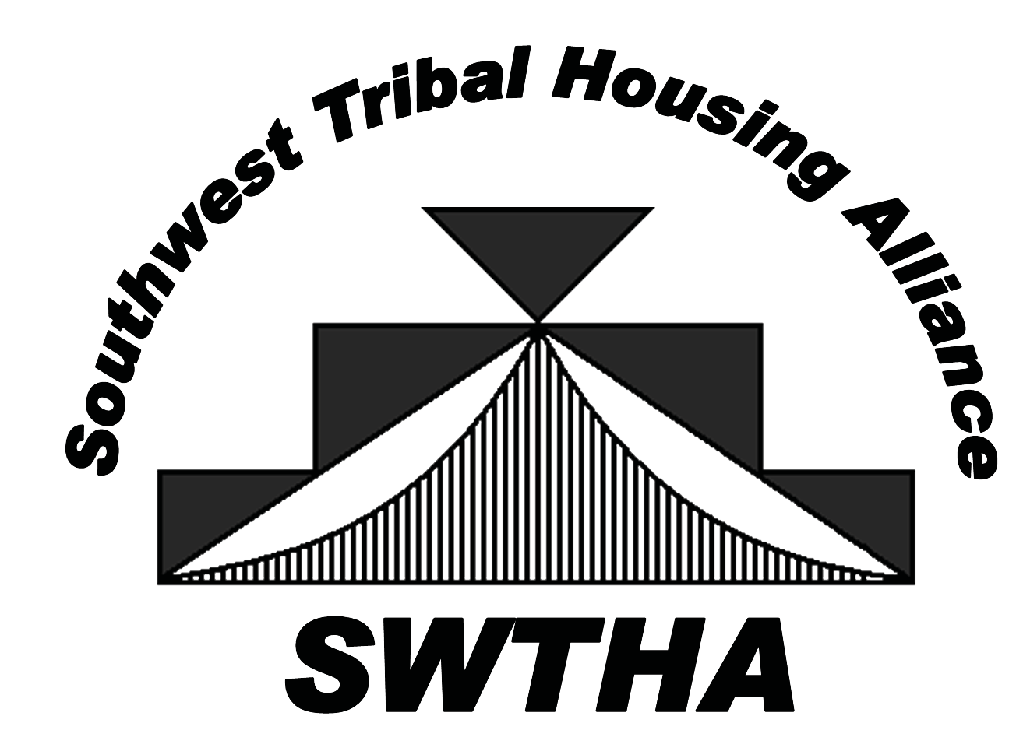
ESTABLISHED IN 2009, SWTHA is a relatively new
organization gaining strength and, as membership numbers increase, the strength of the alliance builds. Through the alliance, Tribal housing authorities support one another to ensure that unique Tribal housing needs and interests are recognized and addressed.

Southwest Tribal Housing Alliance
VISION: Region VIII Tribal Housing Advocate

MISSION: To be the Southwest Tribal voice
of housing by providing relevant, timely information, resources and a valuable network for the SWTHA membership

Region VIII: Representing Arizona, New Mexico and West Texas—Tribes, Pueblos and Nations
Reasons to Join: SWTHA Membership Benefits

■ More members mean a stronger voice for Native families.
■ A reasonable membership fee of only $250 per year.
■ Educational opportunities:
> Technical training and assistance to increase administrative capacities.
> Access to regional and national speakers on regulatory compliance, development, finance, economic development, environmental, legal and other topics related to affordable housing.
■ National and regional advocacy specifically for New Mexico,
Arizona and West Texas Tribal communities.
■ Scholarship opportunity:
> $5,000 awarded annually to the region sponsored by AMERIND Risk Management.
Call, email or visit us!
swtha.region8@gmail.com SWTHA.org
■ Annual Membership Meeting.
■ Strong partnerships with housing organizations such as
the National American Indian Housing Council.
“It is powerful to see the impact an alliance of devoted entities can make in a community. I have seen the members of the Southwest Tribal Housing Alliance do a tremendous job of representing Indian Housing Authorities, TDHEs and Tribes in providing a hand up to deserving families on tribal lands.”

Veronica Ruiz, Board Member
West Texas Representative
(915) 859-9196
vruiz@ydsp-nsn.gov

Brook Kristovich, Board Member
Region VIII NAIHC Representative
(575) 464-9259
bkristovich@
mescaleroapachetribe.com

SWTHA BOARD MEMBERS AND REPRESENTATIVES
Jesus Mora, Board Member
Arizona Representative
(520) 879-5890
Jesus.Mora@pascuayaqui-nsn.gov

Marlene Garcia, Board Member
Arizona Representative
(520) 568-1733
magarcia@ak-chin.nsn.us

Debra Hansen, Board Member
New Mexico Representative
(505) 465-1003
dhansen@sdtha.org

SWTHA BOARD
OF DIRECTORS
William Picotte, President
520-562-3904 william.picotte.DCH@gric.nsn.us

Michael Chavez, Vice President
NAIHC Alternate
(505) 782-4553
mchavez@pozha.org

Nina Jaramillo, Secretary
(505) 771-2060 Nina.Jaramillo@santaana-nsn.gov

Jonathan Robertson, Treasurer
(915) 859-9196
jrobertson@ydsp-nsn.gov

—Floyd Tortalita, former Governor of Acoma Pueblo

Floyd Tortalita, Board Member
Region VIII AMERIND Rep
New Mexico Representative
(505) 552-7528
ftortalita@acomahousing.org

Lisa Manwell, Board Member
Region VIII AMERIND Alternate
(575) 759-3415
lgm@jaha1.org

*Please direct all general inquiries to SWTHA Vice President and membership information to SWTHA Treasurer.

